CHAN SUI KI (LA SALLE) COLLEGE
Extra-curricular Activities Section
Regulations for Organising Extra-curricular Activities

- Guidelines on Activities Outside School Premises
For activities to be held outside school premises, teacher should observe the following procedures in order to ensure the safety of the students concerned:

- Safety of students is the first and foremost concern in outdoor activities. Teachers should be aware of the potential hazards of outdoor activities and the surrounding environment, and take appropriate precautions to ensure safety.

- An application form about the details of the outing should be submitted to the principal for approval.

- A letter bearing the signature of the principal should be given to parents of the students concerned. The reply slips should be collected and kept by the teacher advisors until the end of the activity.

- ‘Guidelines on Outdoor Activities’ issued by the Education Bureau should be read and followed. Please refer to relevant chapters of the documents:
Chapter 1 | Notes for Heads of Schools and Teachers/ Instructors
Chapter 2 | General Measures for Activities on Land
Chapter 3 | Excursion
Chapter 4 | Expedition
Chapter 5 | Camping
Chapter 6 | Orienteering
Chapter 7 | Cycling
Chapter 8 | Fieldwork
Chapter 9 | General Measures for Activities on Water
Chapter 10 | Windsurfing
Chapter 11 | Canoeing
Chapter 12 | Rowing
Chapter 13 | Sailing

- Please observe the staff/student ratio of various outdoor activities.
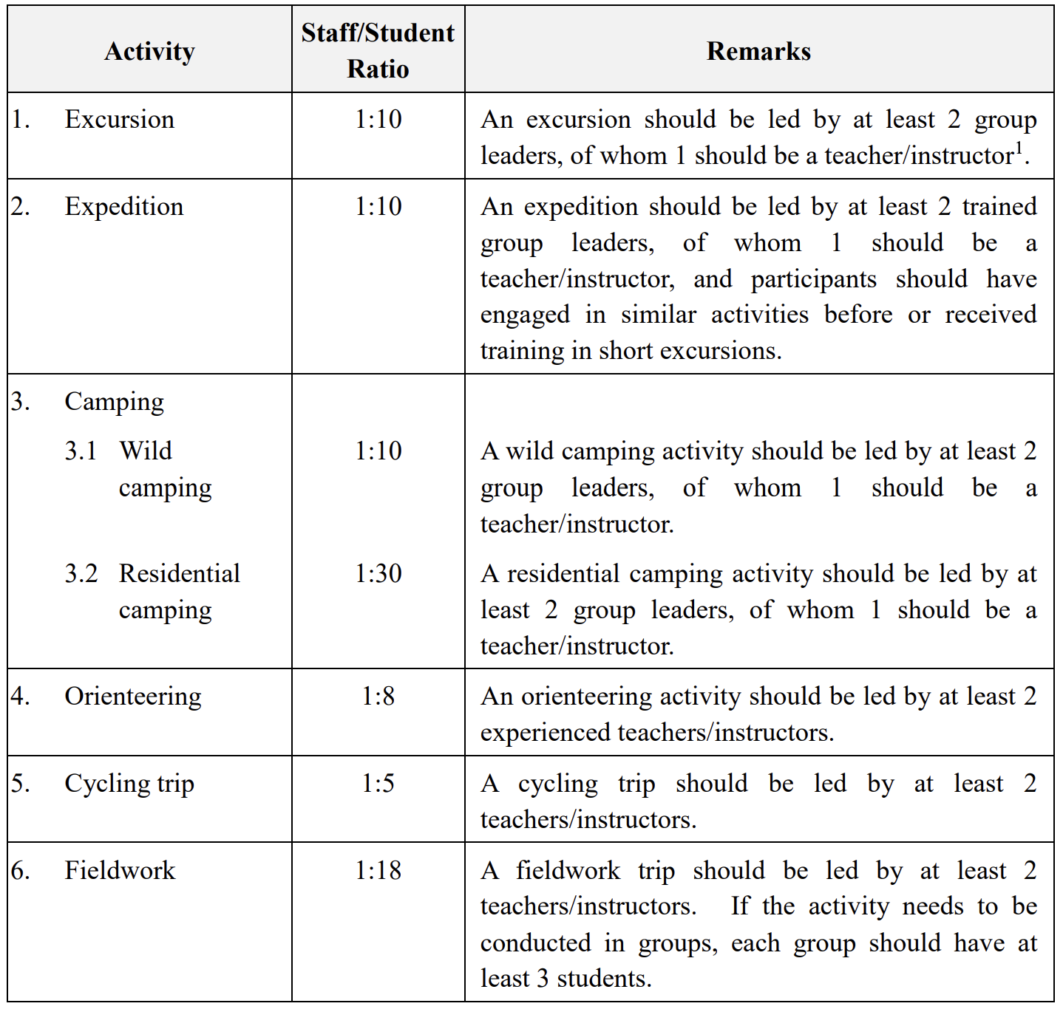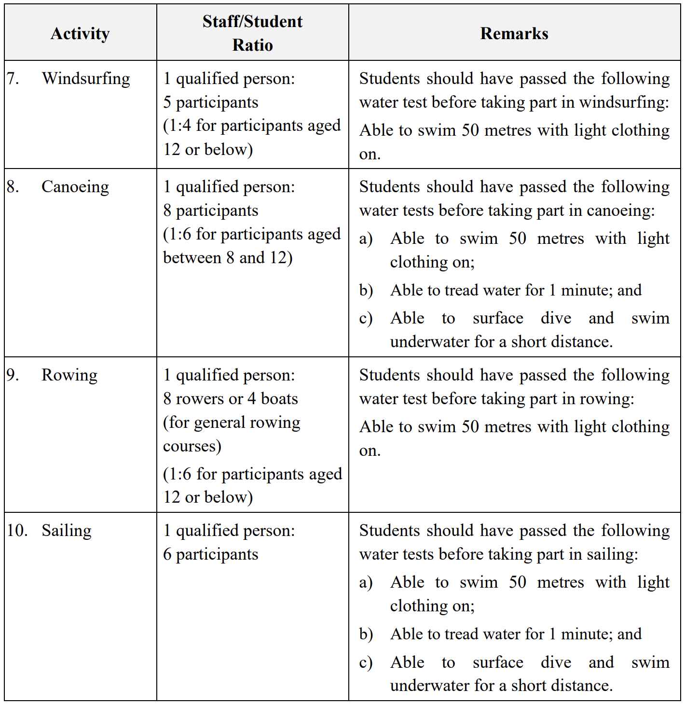

- Teachers/Instructors should take note of the Air Quality Health Index within the activity area. For more information about the Index, please visit the following webpage of the Environmental Protection Department <http://www.aqhi.gov.hk/en.html>. In case the Index has reached the “high”, “very high” or “serious” level of health risk, schools may also refer to the “Dos and Don’ts for Arranging Physical Activities” and the related “Frequently Asked Questions” at Appendix XVI of ‘Guidelines on Outdoor Activities’.

- All outdoor activities should be cancelled if a tropical cyclone warning is issued. If signal no. 1 is issued during the conduct of activity, participants should take immediate shelter in the nearest safe place. As long as circumstances permit, teachers/instructors should make arrangements for participants to return home. When a higher signal is issued, participants should stay at the nearest shelter until safety is no longer threatened by the wind.

- When a thunderstorm warning or a red/black rainstorm warning is issued, teachers/instructors should suspend all outdoor activities immediately and lead all participants to a safe place to take shelter until it is safe to return home. When a thunderstorm warning is issued before the conduct of activity, teachers/instructors should decide whether to postpone or cancel the activity, taking into consideration its nature, content and location.

- When a cold or very hot weather warning is issued, it is expected that cold or very hot conditions will persist. Teachers/Instructors should assess the situation and decide whether to postpone or cancel the activity. In cold weather, participants should be advised to put on warm clothing to prevent hypothermia. When the weather is hot or sunny, teachers/instructors should remind participants to take precautions against heatstroke and excessive exposure to UV radiation. For details, please refer to Appendices XIII and XIV of ‘Guidelines on Outdoor Activities’.

- During the conduct of outdoor activities, teachers/instructors should bring along a first aid kit and personal communication devices such as mobile phones for treatment of injuries and external communication in the event of emergency. When an accident occurs, schools should take immediate actions and notify the parents or family members of the injured student(s) as soon as possible. The accident should be reported to the police immediately if necessary. Details of the accident should also be recorded.

- For each outing in the rural area, the school should:
    - send a fax to the Divisional Commander of the Police Division overseeing the location where the outing will take place, with details of the outing at least 10 days in advance (schools not sure of which Police Division the chosen location falls into may seek advice from the School Liaison Officer of the respective police district);
    - notify the respective Divisional Commander by fax should there be subsequent changes to the above details;
    - remind all participants to bring along their identity documents. Participants over the age of 15 must bring along their proof of identity, including, inter alia, Identity Card or Junior Identity Card; and
    - set up its own monitoring system, which should require a responsible person to report to the police in case no notification about the completion of activity is received at the scheduled time from the outing leader(s).

- The following steps should be taken in case of accidents:
- Perform first aid as and when necessary, and avoid acting hastily if there is any doubt;
- Avoid moving the injured unless it is absolutely necessary. Send the injured to medical service immediately if circumstances permit, or have the help-seeker accompanied while awaiting rescue; and
- Make an initial record by completing the “Proforma for Recording Emergency” for the reference of outside rescuers (please refer to Appendix VI of ‘Guidelines on Outdoor Activities’)
  - location of the injured (name of place, grid reference or the number of the nearest distance posts erected by the Agriculture, Fisheries and Conservation Department every 500 m along hiking trails);
  - time of the accident;
  - condition of the injured;
  - brief particulars of the injured;
  - brief particulars of the informant; and
  - number and condition of persons in the same team

- Duties of Teacher Advisors of Clubs and Societies
- Monitor the operation of clubs and societies, provide guidance and render assistance to the committee members in order to ensure that the activity goals are achieved and effective implementation of the activities is guaranteed.

- Help to establish a committee for each club; make its year plan and prepare financial budgets.

- Attend the committee meetings and actively participate in the activities of clubs and societies. All teacher advisors must attend at least one committee meeting in each term of a school year. Teacher advisors are responsible for monitoring the update of attendance record in all meetings and activities.

- All cash should be kept by chief teacher advisors. Make sure that the committee members handle monetary matters carefully by keeping financial records and inventories of all assets and facilities. If there is insufficient fund for organising activities, all necessary transactions ought to be prepaid by teacher advisors. Teacher advisors can claim the expenses after the activities with the original copies of receipts.

- Teacher advisors can apply for Life-wide Learning Grant if there is insufficient fund for organising activities. Application and claim forms ought to be submitted to the ECA Section by teacher advisors.

- In the course of an activity, make sure that the committee members attend to safety measures to protect the participants.

- All activities conducted outside the school premises should adhere to the teacher-student ratio requirements in the ‘Guidelines on Outdoor Activities’ issued by the Education Bureau.

- Before all outdoor activities are held, teacher advisors should ensure a parent notice is issued. Participant’s name and class ought to be filled in each notice before submitting to the principal for signature. All notices ought to be submitted to the principal at least 2 weeks before the activity is held. The reply slips should be collected and kept by the teacher advisors until the end of the activity.

- Offer guidance to the committee members who need to write a club report which includes (1) a year plan, (2) club and society data, (3) a financial report, (4) attendance records, (5) meeting minutes and activity records and (6) records of external competitions and their results.

- Ensure that at least 3 proper photos are taken in each activity for record.

- Evaluate the performance of each committee member by inputting the following information on e-class:
  - names of eligible committee members
  - committee members’ service hours

- Evaluate the performance of each general member by inputting the following information on e-class:
  - names of eligible general members

- Input on e-class the names of activities and competitions organised by the clubs and societies and taken part in by members of the clubs and societies
- Duties of Teacher Advisors of Interest Groups

Quality assurance
- to conduct observations at least three times throughout the whole school year
- to ensure that the service provider of an interest group submit a final report by the end of the school year
- to complete a year-end evaluation report by the end of the school year

Student participation
- to encourage students of an interest group to take part in competitions outside school

Publicity
- For an activity that has been organised by an interest group, prepare a short summary of the activity and at least 6 photos taken during the activity within two weeks after activity is organised. The information will be published on the school website under “News”.

Respective roles of chief teacher advisors and teacher advisors
Roles of chief teacher advisors
- Liaise with service providers
- Handle financial matters

Roles of teacher advisors
- Review the mid-year club report and annual club report prepared by the Chairman of an interest group

Roles shared by chief teacher advisors and teacher advisors
Examples:
- Sit in on student meetings
- Accompany students to outside school activities
- Coordinate student showcase events
- Arrange for students to take part in related external competitions
- Review the evaluation report submitted by service providers
- Evaluate the Interest Group by filling in a standard evaluation form. The form has to be attached to the Annual Club Report.
- Prepare a summary of the activities held by the interest club at the end of the school year on the school website
- Others

- Registration of Clubs and Societies
- Every teacher is assigned to be the teacher advisor of no more than two clubs and societies. Teacher advisors should play an active role in the supervision of the activities of the clubs and societies.

- Teacher advisors should help to establish a committee for the clubs and societies and submit the list to the ECA Mistress by September.

- The chairman training course will be held in the first week of the school year.

- The first committee meeting is suggested to be held by late-October every year.

- The Club Year Plan should be submitted before Recruitment Days and Member List ought to be submitted by mid-October.

- The membership fee for joining each club/ society is $50, with the exception of (a) Aerospace Society, (b) Red Cross and (c) Scout. The membership fee for joining each interest group is $500.

- The amount of money collected for each activity should not exceed the budget of all items of expenditure. After deduction of cost, the surplus beyond 15% of the total expenditure should be refunded to participants. If the surplus is within 15% of the total expenditure, the surplus can be kept by clubs and societies.

- Guidelines on participating in ECA

Participation

Secondary 1
- Students should choose
- at least one but no more than 2 items under A1) School Teams (teams 1-9), A2) Uniform Groups and A3) Instrumental Classes; and
- no more than one item under B4) Interest Groups; and
- at least one but no more than 2 items under B2) Religious and Service Groups and B3) Art Groups; but
- at most no more than three items under A1) School Teams (teams 1-9), A2) Uniform Groups and A3) Instrumental Classes, B2) Religious and Service Groups, B3) Art Groups and B4) Interest Groups

Secondary 2 to Secondary 5
- Students may participate in
- A1) School Teams (members are selected by teachers)
- A2) Uniform Groups and A3) Instrumental Classes

- Students should choose
- at least one but no more than two items under B2) Religious and Service Groups, B3) Art Groups and B4) Interest Groups,
- no more than one item under B4) Interest Groups

Secondary 6
- Students may participate in
- A1) School Teams (members are selected by teachers)
- A2) Uniform Groups and A3) Instrumental Classes

- Students should
- choose no more than one item under B2) Religious and Service Groups and B3) Art Groups
- not choose any item under B4) Interest Groups

Requirements for membership to be shown in report card for S1-S5 students
To be decided by individual teachers-in-charge
A1) School Teams
A2) Uniform Groups
A3) Instrumental Classes

Take part in at least two activities
B2) Religious & Services Groups
B3) Art Groups

Attend at least 60% of sessions
B4) Interest Groups

Remark: No membership of any of B2), B3) , B4) will be shown in the report cards of S6 students.

- Procedures for Clubs and Societies Using School's Special Rooms/ Hall/ Playground
- Book special room or playground one day in advance in the office. Book the school hall one week in advance in the office.

Students who wish to book a room/hall/playground must present the application form with the signature of the club's advisor and the venue responsible teacher.

The teachers named below are responsible for the following rooms/playground:
School playground V Vong
Art room SH Leung
Music room YM Chan
Geography room TH Lin
Lecture room YY Lam
Student Activity Centre YY Lam

- Borrow the key from the office before the start of a meeting and an activity. The key must be returned to the office immediately after use.

- All meetings and activities should end by 6:00 p.m. A teacher advisor or a committee member must be responsible for the meetings and activities. For activities held in Student Activity Centre, students must be accompanied by a teacher advisor.

- Keep the room clean and tidy.

- Turn off the fans, lights, air-conditioners and all electric appliances before leaving the room.

- Get the key from the office or janitor staff and lock the door after the meeting and activity.

7. Organisation of Extracurricular Activities
(i) All external correspondences must be submitted to the Principal two weeks in advance for approval.

(ii) Each club is assigned a notice board on the covered playground of the school. Year plan and Committee Member List must be posted up. Clubs & societies are encouraged to use the club notice boards for notifying members of their forthcoming activities.

(iii) Internal posters or promotion materials must be submitted to the teacher advisors and ECA mistress for approval before any of these may be posted up or distributed. Possible means of publicity include:
  - 7 posters are suggested to be prepared to be posted from G/F to 6/F. The signed posters should then be submitted to the school office for posting.
  - Notice boards of individual classes
  - TEAMS (Form Coordination Activities)
  - Communication with general members using social media platforms

(iv) Each club will be allocated a locker on 6/F. Keep the locker clean and tidy.

(v) Responsibilities of Clubs & Societies:

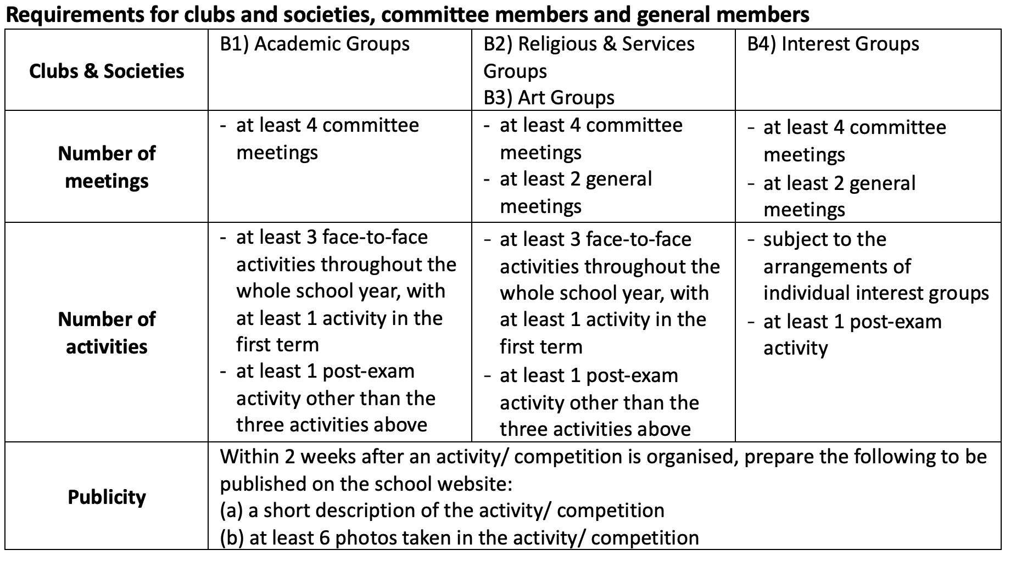
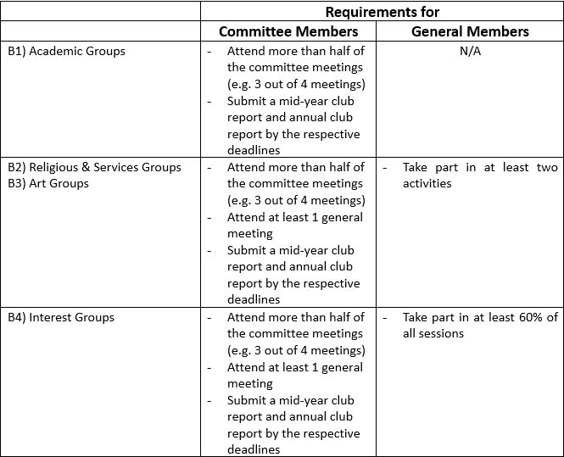

8. Guidelines on Activities in Case of Inclement Weather
(i) If the following signals are hoisted by the Observatory of HKSAR after 5:30 a.m., all outdoor activities will be cancelled. Students need not report to teachers at the meeting place or go to school.
a. Any tropical cyclone warning signal
b. Black or red rainstorm signal

- All indoor activities will be cancelled under the following situations.
a. Tropical cyclone warning signal number 8 or above
b. Black or red rainstorm signal

- In case of inclement weather or amber rainstorm signal, students should report to teachers at the meeting place and teachers should take attendance as scheduled. The decision as to whether outdoor activities should be cancelled is left to the teacher-in-charge, who should exercise his discretion with reference to the weather report.

If the final decision is to cancel the outdoor activities, the teacher-in-charge should immediately report to the school office by phone and all students should go home at once.

9. Guidelines for Organizing Barbecues and Hot Pot Activities Inside School Premises

(i) School should consider and satisfy the following criteria when planning for barbecue or hot pot activities (with electric cooker only) in school:
- There is a genuine need of the school to hold such an activity on school premises.
- The activity should be held after normal school hours.
- All fire safety measures listed on the “Fire Safety Recommendations for Barbecue and Hot Pot Activities” provided by the Fire Services Department (FSD) below should be satisfied and observed.

(ii) When organising barbecue and hot pot activities, school should conduct risk assessment to determine the upper limit of participants for any particular locations.

Barbecue activities
From fire safety point of view, the upper limit in the number of participants will depend on whether there are sufficient school staff supervising the safe conduct of the barbecue and whether the location of the school premises for barbecue is suitable and safe. For example, more school staff is required for looking after younger students than those in the upper forms. Parents may be enlisted to assist in supervising the barbecue.

Hot pot activities
School should assess whether the location for hot pot activity is adequately spacious and with sufficient emergency exits to safely accommodate the number of participants where such activity is being conducted. When deciding on the upper limit in the number of participants of hot pot activity for a particular location, school should consider the following:
- whether the number of exits at the location is sufficient should an emergency occur which necessitate an immediate evacuation;
- the number of supervising school staff;
- the age of students taking part;
- the tripping hazards of electric cable, extension board, etc., lying on the floor;
- the stability of the table on which the hot pot and electric cooker are placed;
- the stability of the cooker and the pot; etc.
- the adequacy of means of escape of a classroom with reference to the design population/ capacity and the number and width of exits in accordance with the “Code of Practice for the Provision of Means of Escape in case of Fire 1996”. For other rooms, the upper limit of accommodation should not exceed the figure allowed on the latest plan (i.e. usually shown on the means of escape table) approved by the Buildings Department (BD). If school does not have a copy of the record plan for such information, school may approach the Building Information Centre of BD to view the latest approved plan record. In case school wishes to exceed the limit, the service of an Authorised Person to reassess the upper limit of the room is required.

(iii) Wet or humid weather will affect the safe conduct of hot pot activity in the open ground. The electrical insulation of electrical appliances, wiring, extension board, etc., are adversely affected by humidity, dampness, rain, water, etc., unless they are of the weatherproof types. The use of electrical appliances and equipment in wet or humid weather may cause short circuits and electric shocks. Hence, hot pot activity in schools in the open ground is NOT recommended. In this respect, schools may refer to the relevant safety publications available at the “Electrical and Mechanical Services Department” website for ensuring electrical safety.

https://www.edb.gov.hk/attachment/en/sch-admin/admin/about-activities/sch-activities-guidelines/Outdoor_EN.pdf

